1. Task Objective

To design the algorithm and write a C++ program that will determine which one of the two OMAHA Hi/Lo poker hands is the winning hand for High and which one is the winning hand for Low (if any).

The purpose of the test is to evaluate applicant’s ability to understand the requirements and implement the algorithm that accurately meets all of them. The knowledge of Poker is not required or expected, any information needed to complete the test is contained in this document.

The applicant is expected to design the algorithm and necessary data / class structures to provide implementation that is robust, logical and easy to understand. It is not necessary to validate the input or provide any other error handling in the implementation.

2. Notation

In this document we will use a two-character notation for cards that will show the card rank and the card suit, for example:
Ad (Ace diamonds)
Kc (King clubs)
Qh (Queen hearts)
Js (Jack spades)
Td (10 diamonds)
9s (9 spades)

3. Poker Rankings
3.1 Poker rankings for High Hand
Poker High rankings for any hand containing 5 cards are defined in the following order - from highest to lowest (examples shown):

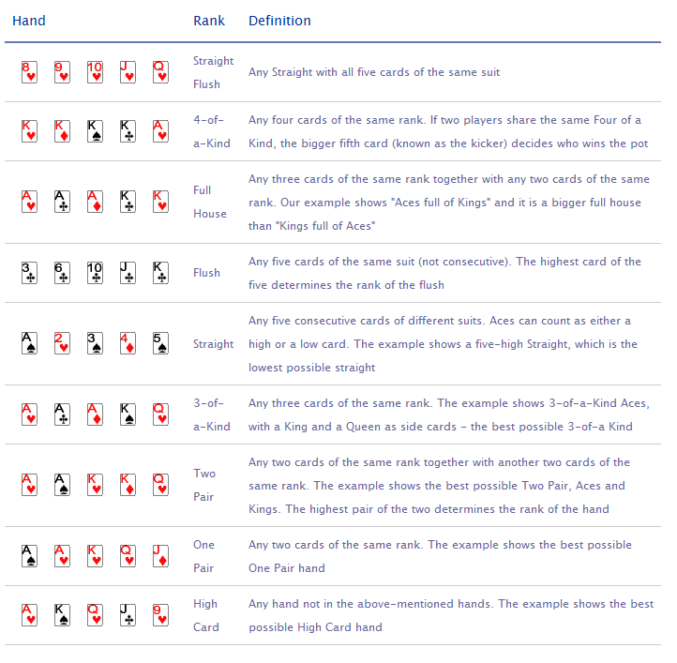

If two hands are of the same ranking, the winner is the one having the higher cards. For example, a Flush with an Ace high beats a Flush with a King high. If the highest cards of each hand are of the same rank, then it is the highest card not being held in common (called the "kicker") that determines the winner. For example, One Pair As-Ad-Qh-Jd-9c wins against Ac-Ah-Qs-Jc-8d using the "9 kicker".

In the event of hands being absolutely identical in ranking, it is a tie and the pot will be split evenly between the two or more winning players.

Notes:
a) In Poker unlike Bridge the suit has no impact on the ranking (e.g Ks is as strong as Kd)

b) An Ace can be used in straights as the highest card or as the lowest card.
For example, the following hands are both straights: As-Kd-Qd-Jd-Tc and
5c-4c-3d-2s-Ad (but the hand 4c-3d-2s-Ac-Kd is not a straight, but High Card).

c) When two hands of "Full House" ranking are compared, 3 of a kind are compared first. For example, A-A-A-5-5 wins against K-K-K-Q-Q

d) When two hands of "Two Pair" ranking are compared the higher pairs are compared first. For example, K-K-2-2-5 wins against Q-Q-J-J-T.

3.2 Poker rankings for Low 8 Hand.

There are two required qualifications for a hand with 5 cards to qualify for low-8 hand:

a) All 5 cards should have different rank

b) None of the cards should be higher than 8. Aces are always considered to have the value of 1 for low hand evaluation.

Any qualified low hand beats a hand that did not qualify for low. If no hand qualifies for low, then all chips are awarded to the winner(s) of the high hand.

Example of hands which don't qualify for low:

ATQ23: some cards higher than 8
95432: some cards higher than 8
73322: not all cards are of different ranks

If both hands qualify for low, the hand containing higher card loses, i.e. 5432A beats 86743. If senior card or cards are equal, then the first card that is different decides the hand. For example, 7632A beats 76432, because the third card for the second hand is higher than the third card for the first hand.

4. Omaha Hi/Lo Definition

In OMAHA Hi/Lo each player receives 4 cards and 5 cards are placed on the board seen by all players. A player must combine any two of his cards with any three cards from the board to obtain 5 cards with the highest possible ranking for high hand, and combine any other (or same) two of his cards with any other (or same) three cards from the board to obtain 5 cards with lowest possible low hand.

It is important to realize that in all cases best 5-card combination of one player will be compared to best 5-card combination of another player to determine the winner.

5. Program Requirements

The program OMAHACOMP should read 2 parameters from the command line:
omahacomp.exe input.txt output.txt
input.txt contains the list of card combinations
- HandA:card1-card2-card3-card4
- HandB:card1-card2-card3-card4
- Board:card1-card2-card3-card4-card5
Each line contains the whole combination, such as
HandA:Ac-Kd-Jd-3d HandB:5c-5d-6c-7d Board:Ah-Kh-5s-2s-Qd

output.txt should contain the results of hand evaluation, including input line, winner hand and combination for High and Low hands (see examples below for required format).

The full rank of each hand should be taken into consideration when comparing two hands, but for simplicity the displayed rank should be just the major rank without naming the kickers, etc.

6. Examples

omahacomp input.txt output.txt

input.txt:

HandA:Ac-Kd-Jd-3d HandB:5c-5d-6c-7d Board:Ah-Kh-5s-2s-Qd
HandA:Ac-Kd-Jd-3d HandB:5c-5d-6c-6d Board:Ad-Kh-5s-2d-Qd
HandA:Qc-Jd-Td-3d HandB:Tc-Jc-8h-6d Board:Ad-Kh-Qs-2d-3c
HandA:Qh-4d-Tc-8s HandB:Qc-8c-7d-2h Board:Ad-As-3c-3d-5d
HandA:Ah-2s-Qd-9S HandB:Ac-2d-6s-Jh Board:Kd-4h-Kh-5s-3c
HandA:Ah-2s-Qd-9S HandB:Ac-2d-As-Jh Board:Kd-4h-Kh-5s-3c
HandA:6d-6c-Kc-4d HandB:Jh-Js-Qs-8h Board:2s-3h-9c-As-Ac
HandA:6d-Kh-Ac-4d HandB:Jh-2s-Ah-8h Board:Js-3h-9c-As-6c
HandA:Qc-Jd-Td-3d HandB:3s-3h-8h-6d Board:Ad-Kh-Qs-Qd-3c

output.txt:

HandA:Ac-Kd-Jd-3d HandB:5c-5d-6c-7d Board:Ah-Kh-5s-2s-Qd
=> HandB wins Hi (3-of-a-Kind); HandB wins Lo (7652A)

HandA:Ac-Kd-Jd-3d HandB:5c-5d-6c-6d Board:Ad-Kh-5s-2d-Qd
=> HandA wins Hi (Flush); No hand qualified for Low

HandA:Qc-Jd-Td-3d HandB:Tc-Jc-8h-6d Board:Ad-Kh-Qs-2d-3c
=> Split Pot Hi (Straight); HandB wins Lo (8632A)

HandA:Qh-4d-Tc-8s HandB:Qc-8c-7d-2h Board:Ad-As-3c-3d-5d
=> HandA wins Hi (One Pair); HandB wins Lo (7532A)

HandA:Ah-2s-Qd-9S HandB:Ac-2d-6s-Jh Board:Kd-4h-Kh-5s-3c
=> HandB wins Hi (Straight); Split Pot Lo (5432A)

HandA:Ah-2s-Qd-9S HandB:Ac-2d-As-Jh Board:Kd-4h-Kh-5s-3c
=> Split Pot Hi (Straight); Split Pot Lo (5432A)

HandA:6d-6c-Kc-4d HandB:Jh-Js-Qs-8h Board:2s-3h-9c-As-Ac
=> HandB wins Hi (Two Pair); HandA wins Lo (6432A)

HandA:6d-Kh-Ac-4d HandB:Jh-2s-Ah-8h Board:Js-3h-9c-As-6c
=> HandB wins Hi (Two Pair); HandB wins Lo (8632A)

HandA:Qc-Jd-Td-3d HandB:3s-3h-8h-6d Board:Ad-Kh-Qs-Qd-3c
=> HandA wins Hi (Full House); No hand qualified for Low

7. Deliverables

The result of the test should be:

- the source code
- brief descriptions of the algorithm
- fully debugged executable which must run on any Win OS in plain DOS mode. Make sure that executable is compiled in a release mode and does not req1uire additional software components to run.

There is no need to verify the integrity of the input (i.e. duplicate cards, wrong syntax, etc).

There is no need to have the absolute best performance - just a reasonable balance between complexity and performance.

The applicant is not allowed to use external poker related references and resources for designing the algorithm and writing the program.

8. Help

The task description is intended to provide all necessary information for a successful solution. However, if you encounter a blocking question you may contact brendai@pyrsoftware.com during the first hour starting from the test reception.

